# **Home Learning Task: Intro to Database – session 1**

Task: Create a table with a primary key and the correct datatypes. Include a minimum of 5 fields. View the table structure to make sure it is setup correctly

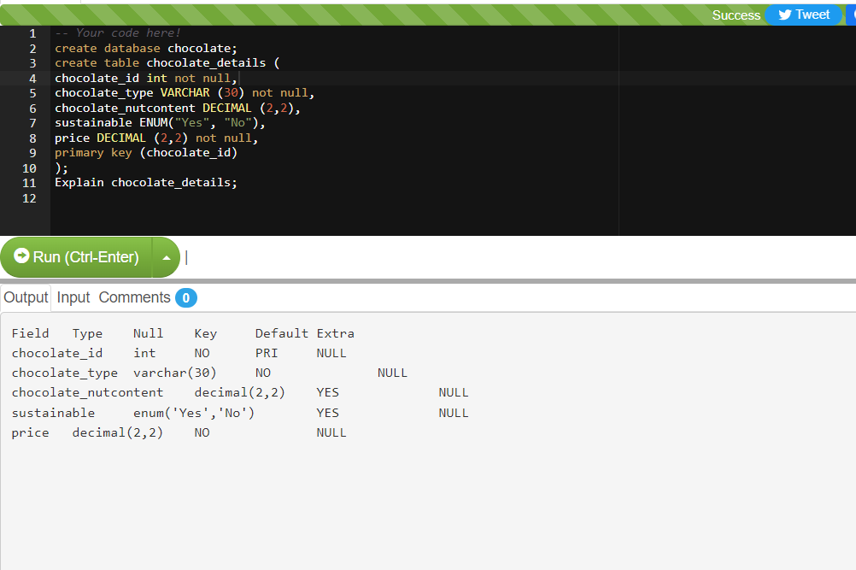

A chocolate data base is created to store the following data

* Chocolate ID number
* Chocoloate Type (e.g white, dark, milk)
* Chocolate nut content (%)
* Sustainably sourced (Yes/ No)
* Price

The primary key is the Chocolate ID number

# **Home Learning Task (Part 2): Intro to structure Query Language – session 2**

Task: Create a relational database (2 tables) of your own choice. It is must be a meaningful/thought out database

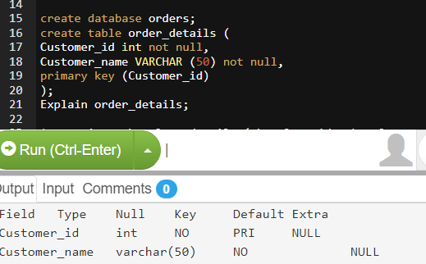

Task: Both tables must have a primary key and the correct datatypes. Include a minimum of 5 fields in at least one of the tables. • View and show both table structures and data to make sure they are setup correctly. • Enter records into both tables and view them. Make sure at least one of your tables has 10 records.

2 tables have been created; table 1 (shown above) contains information on the chocolate, whilst Table 2, shows information about the orders that have been placed.

Below demonstrated the records that have been inputted into the database for both tables:

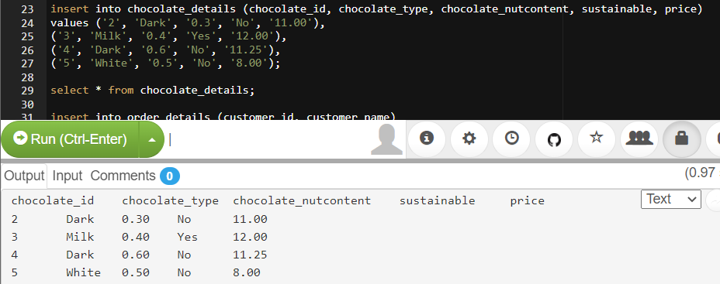

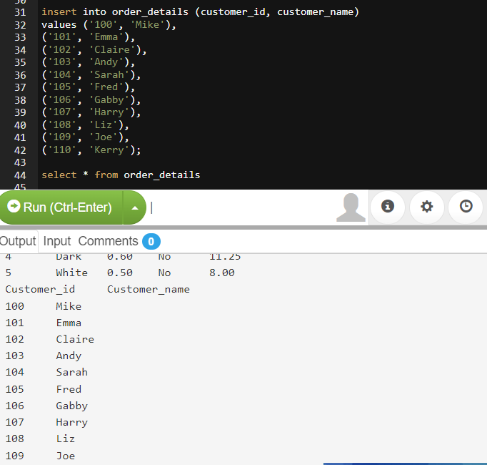

Task: • Update a record • Delete a record

Update: The record for customer ID 105 has been updated from ‘Fred’ to ‘Ben’

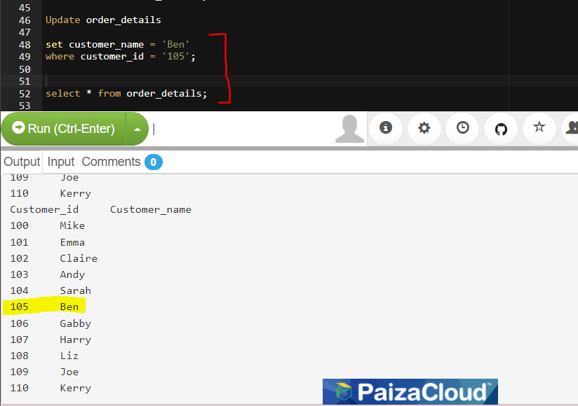

Delete: The record for customer_ID: ‘100’ (customer_name: ‘Mike’) has been deleted from the order_details database.

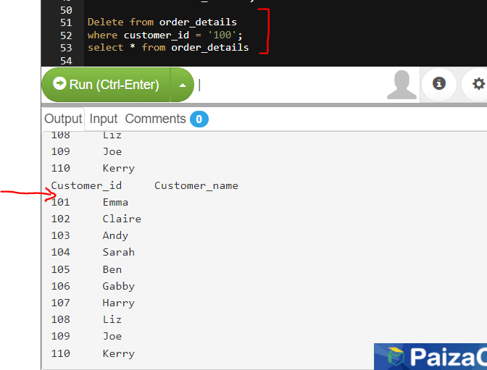

Task: Creating an inner join:

I have created an inner join with matching variables of Chocolate ID, with the chocolate table and orders table.

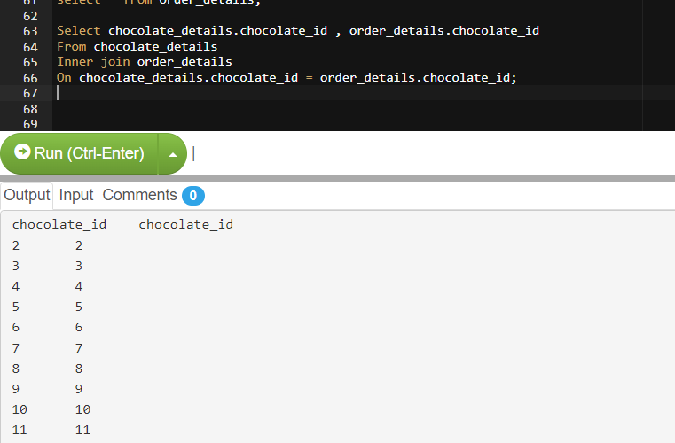

Task: • Run a complex query (more than one field/column) to demonstrate the relations between the 2 tables.

A query was run to identify the record where an order has been identified with a customer name in the order table being “Kerry”. We see the full record of the order that was made by Kerry ordering a Banana flavoured chocolate at £7.00

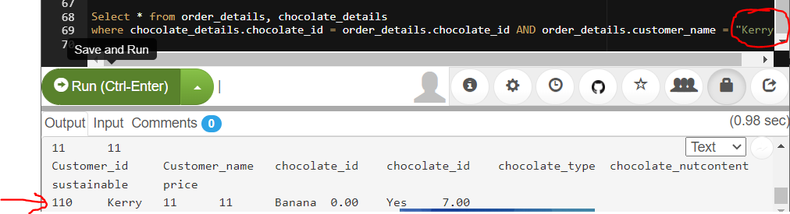

Task: • Retrieve all your data sorted in ascending order on an appropriate field (one table)

The column Customer_name was set in alphabetical order to order the list of the names within the order_details table.

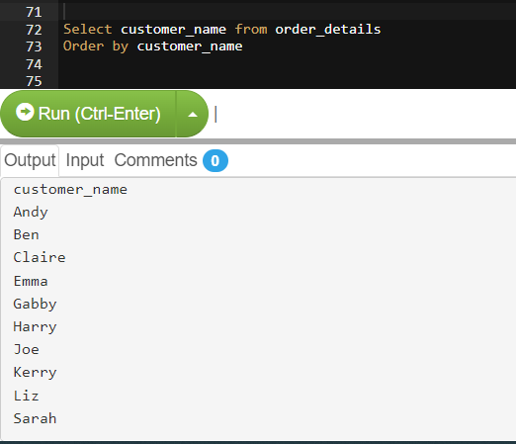

Task: • Filter data using comparison operators (one table)

A comparison filter is used to draw out all of the records on the chocolate_details table that are priced between £11.00 and £15.00 only

